UDC 530.1; 538.97; 539.216.1; 539.216.2; 539.23

ELECTRICAL PROPERTIES OF SILICON NANOWIRES UNDER AMMONIA ADSORPTION CONDITIONS

Dikhanbayev K.K.¹, Bondarev A.I.², Shabdan E.¹, Ykramova S.B¹.
¹National Nanotechnology Open Laboratory, Almaty, Kazakhstan, dkadyrjan@mail.ru
²al-Farabi Kazakh National University, Almaty, Kazakhstan

When monitoring the environment, measurements of the concentration and composition of the gas phase of various substances are of great importance. To solve such problems, resistive-type semiconductor sensors are of interest. The proposed sensors based on silicon nanowires have several advantages: high sensitivity and possibility to work at room temperature. This in turn simplifies the design and reduces the cost of the sensors. All this indicates the relevance of the investigated gas sensor.

Keywords: silicon, nanowires, electrical properties, metal-assisted chemical etching, current-voltage characteristics, sensor.
Introduction
This work aims to create a new type of gas-sensitive material based on hetero-structured the p- Si/SiNWs (p type Silicon/Silicon nanowires). Finding new materials for gas sensors is particularly relevant for monitoring environment, in medicine, automotive industry and subways etc. [1-2]. To solve the various problems of determining the composition of gas phase, the resistive-type semiconductor gas sensor has attracted great interest [3]. The working principle of such sensors is based on the effect of changing the electrical conductivity of semiconductor materials in the presence of trace amounts of oxidizing gases or reducing agents. Silicon nanowire-based sensors have the following advantages: high sensitivity, compactness, low cost, and the ability to integrate into modern information systems.
In the conventional resistive type gas sensors, the gas sensitivity mechanism includes surface chemisorption process with the change of the carrier concentration in the volume of semiconductor. Overall changes in the electrical conductivity of semiconductor materials (for example, the use of tin dioxide [4] with conductivity and light transmission) can form a sensory response. It is promising to create local interfaces between materials such as silicon nanostructures with various electronic properties [5-6]. In such a system, the chemical absorption process will determine the energy barrier height of the carriers at the nanostructure boundary which will lead to gas sensitivity. The literature [7] contains data on the gas-sensitive characteristics of metal-semiconductor heterojunctions (heterostructures), and its mechanism of action is related to changes in the Schottky barrier height at the hetero-interface. For such materials, high sensitivity value for hydrogen is obtained.
The aim of this work is to study the characteristics of changes in the chemical composition on the resistive properties and surface structures of silicon nanowires and sensitivity to ammonia, as well as the photosensitivity of silicon nanowires in the process of adsorption and in the absence of ammonia.
1. Experimental methods
Initially, p-type single crystal silicon was used, which was doped with boron, and the resistivity was 10 Ohm ∙ cm. Silicon nanowires (SiNWs) layer to the p-layer is mainly obtained by metal-assisted chemical etching (MACE). In this method an HF: H₂O₂ electrolytes used, initially depositing a silver or silver coating on the silicon surface, and then subsequently etching it with metal particles. Etching is carried out in the absence of power requiring very little time and is simple to manufacture. The mechanism of this wet etching of silicon is very different from the conventional electrochemical anodization in porous silicon [8-9]. Finally, strips of component with a SiNWs/p-Si structure were manufactured with a size of (1x10) mm².
Nanostructured silicon nanowires using a transmission electron microscope examination is shown in Figure 1. Analysis of the results of silicon nanowires on SEM microstructures showed that the half-width of nanowires is 20-50 nm, but the presence of ammonia on the surface significantly affects the surface morphology of silicon nanowires, the roughness is about 200 nm. Furthermore, the roughness height of the plate (in the inset of Figure 2) was about 50 nm. The nanostructured sample of the gas sensor prepared in this way was tested for the conductivity of the porous structure based on the presence of steam in the atmosphere of ammonia. The samples were tested in a specially designed light-protective box measuring 10x10x10 cm³.The design of the sensor structure with SiNWs/p-Si is shown in Figure 2.

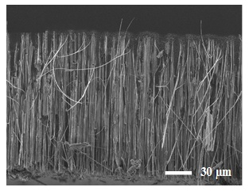 |  | 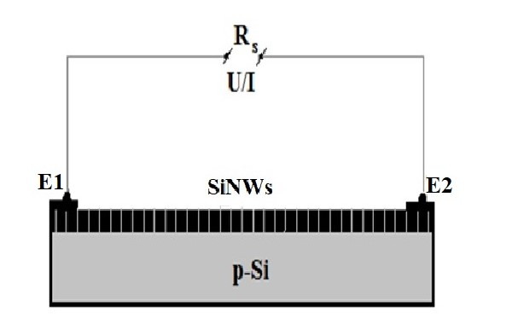
Fig. 1. SEM image of a cross section of a silicon nanowire formed by chemical wet etching. |  | Fig. 2. Sensor Design.
- Discussion of results
The changes of overall resistance R_{s} during gas adsorption on the surface of silicon nanowires through electrodes E1 and E2 was observed with the ohmmeter, the I/V characteristics of the silicon nanowires were measured on an NI ELVIS II⁺(1000 Ms/S Oscilloscope) characterizer. I/V characteristics are shown in Figure 3 in the presence of ammonia vapors with illumination and without ammonia and no illumination. The volume resistance measured via contacts E1 and E2 is 24 kOhm. It can be seen that in the presence of ammonia vapors, the reverse currents of the left branch of the I/V characteristics increase; when illuminated with light, the forward bias with ammonia (blue line) increases significantly compared to nanowires without ammonia. However, the highest volume resistance of the SiNWs sample is about 36 kOhm with the introduction of ammonia vapor, the reverse branch of the I/V characteristic showed a high sensitivity to ammonia impurities. The increases in 6 times in sensitivity is shown in Figure 4. An increase in the SiNWs bulk resistance to 45 kOhm leads to an increase in the reverse and forward bias of the electrical characteristic; for a pure SiNWs (green curve), a forward bias expands the space charge region to 5 V, then increases, similar to the rectifying property of a conventional diode. When exposed to ammonia, the sensitivity of forward and reverse currents increases significantly, however, with the advent of forward bias, the space charge region appears and then increases linearly. Exposure to light dramatically increases reverse and forward bias currents by a factor of 5 compared to the original SiNWs without ammonia. Therefore, the measurement of the sensitivity of the SiNWs structure to the gas vapors presence on the surface layer was determined by the change in resistance caused by the charge carrier dispersion in the darkness and under LED lighting as a function of time, as well as due to an increase in the reverse and forward bias currents of the I/V characteristics.
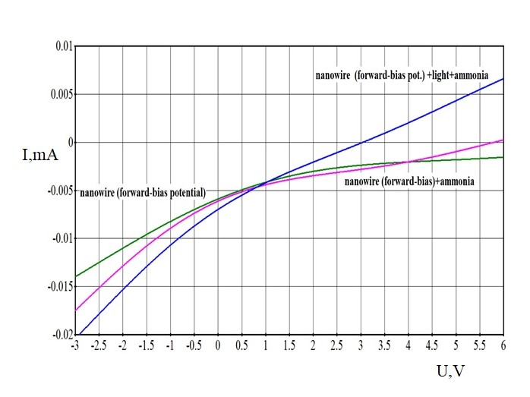
Fig. 3. Electrical characteristics of silicon nanowires

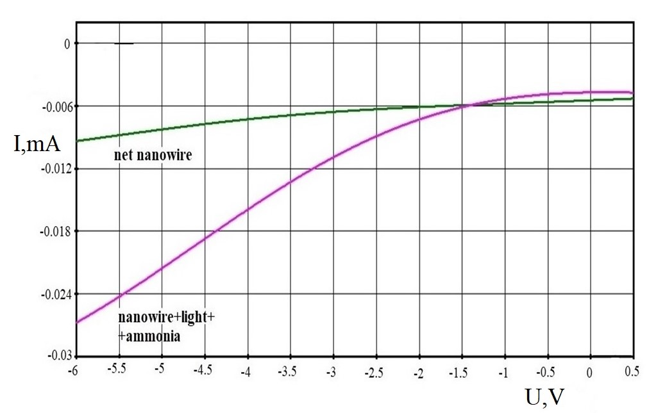
Fig. 4. I-V reverse branch of SiNWs

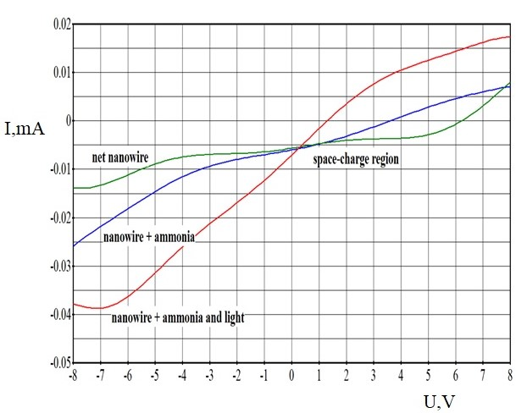
Fig.5. I-V reverse branch of SiNWs
The parameters used to change ammonia vapor sensitivity without and with LED lighting are shown in Figure 6. The change in silicon nanowire resistance in the presence of ammonia vapor in the atmosphere with and without illumination depending on time is shown in Figure 6. After enter in ammonia vapor, the measuring box was opened after 5 minutes and the concentration of ammonia vapor slowly was decreased due to vapor diffusion into the surrounding atmosphere.

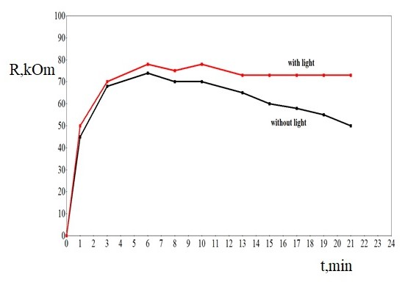
Fig.6. Changes in the resistance of the SiNWs in the presence of ammonia vapor in the atmosphere without/with LED lighting depending on time

A significant change in the resistance of the spreading layer was detected in an atmosphere of ammonia vapor. Furthermore, when lighting was observed, the resistance was observed to recover very slowly from the original value (without ammonia). In contrast, the recovery is much faster in the absence of lighting, which indicates a higher sensitivity to low concentrations of ammonia in the atmosphere when illuminated. It is important to note that although the SiNWs/p-Si structure is an isotype p-type transition; its photoelectric properties are not only very sensitive to the presence of ammonia, but also very sensitive when illuminating the surface of silicon nanowires.
In addition, the chemical etching of the silicon surface of the metal-assisted sensitive layer will lead to an increase in effective surface area, an increase in surface state density, and a formation of deep energy level in the semiconductor band gap caused by atoms of the electrode material and dislocations, which together will allow us to vary the sensitivity and selectivity of the sensory gases.
We have shown that the gas sensitivity and photosensitivity of silicon nanoparticles can be controlled not only by the direct branch of the I/V characteristics, but also by its reverse branch of the curve. We found that this dependence was repeated during the measurement of the I/V characteristics of the samples over five measurements; however, the space charge region at the interface between the SiNWs and crystalline silicon changed with increasing bulk resistance of silicon nanoparticles.
The accuracy of the measurement results of the I/V characteristic depends on the porosity of silicon nanowires and the influence of the environment on the structure of nanoscale filaments aging with storage time in the air, as a result of oxidation, the crystallite size decreases due to the quantum-size effect. However, this effect does not affect the formation of the I/V characteristics.
The novelty of the work is that, for the first time, silicon nanowires obtained by wet chemical etching of the surface of crystalline silicon were used as a sensor device. It was shown for the first time that gas and photosensitivity can be determined from the deviation of the branch of the reverse currents of the I/V characteristic. In addition, from the I/V characteristics, with an increase in the volume resistance of nanostructures, the space charge region (from the straight branch) expands, current rectification occurs at high voltages (for example, in Figure 3).
Conclusion
Earlier, the authors studied sensors based on porous silicon [10-11], and other coatings of the SnO₂ [12-13] and ZnO [14] type, etc. We presented samples of silicon nanowires (SiNWs) and examined sensors of a gas-sensitive element in which nanowires were surrounded by silicon and silver oxides, since on the surface nanowires are passivated by silver nitride. This fact also indicates the photoelectric properties of the sensor device. Silicon nanowires structure has been formed by metal-assisted chemical etching with size of 20 - 50 nm. The shape of the silicon nanowires shown the different diameters of silicon rod nanowires which measured by the SEM.
The forms of silicon nanowires measured in a transmission electron microscope are silicon rod nanowires with different diameters. The effect of ammonia vapor on the electrical properties of the silicon nanowire is shown for the different layer resistance of nanowires. The results showed that the presence of ammonia in SiNWs significantly increases the sensitivity of the reverse and forward branching of features without the need to illuminate the nanowire surface. In particular, the sensitivity to ammonia increased 6 times when illuminated by LED lights.
It was found that with an increase in the etching time for silicon nanowires, the space charge volume in the SiNWs increases which determines the threshold voltage at which the direct voltage of the direct branch of the electrical characteristic increases, and this threshold is 5 V. The relative change in the layer resistance as a function of the time of exposure to ammonia vapor was measured, and when ammonia vapor was removed in the darkness and with light. It is shown that when ammonia vapors are removed without illuminating the sensitivity, the SiNWs slowly decreases to 50% during 22 minutes.
References
- Buturlin A.I. et al. Gas-sensitive sensors based on metal oxide semiconductors. Foreign Electronic Technology, 1983, No.10, pp. 3 - 39. [in Russian]
- Dey A. Semiconductor metal oxide gas sensors: A review. Materials Science and Engineering: B, 2018, Vol. 229, pp. 206–217.
- Fau P., Sauvan M., Trautweiler S., et al. Nanosized tin oxide sensitive layer on a silicon platform for domestic gas application. Sensors and Actuators. 2001, Vol.78, pp. 83–88.
- Barsan N., Weimar U, Understanding the fundamental principles of metal oxide based gas sensors; the example of CO sensing with SnO₂ sensors in the presence of humidity. Journal of Physics: Condensed Matter. 2003, Vol. 15, No. 20, pp. 813 – 839.
- Vashpanov Yu.O., Smyntyna V.A. The adsorption sensitivity of semiconductors. Odessa: Astroprint. 2005, p. 216 [in Russian]
- Oleksenko L.P., Maksymovych N.P., Sokovykh E.V., et al. Study of influence of palladium additives in nanosized tin dioxide on sensitivity of adsorption semiconductor sensors to hydrogen. Sensors and Actuators B: Chemical. 2014, Vol. 196, pp. 298–305.
- Sechenov D.A., ZakharovA.G., Nabokov G.M. Electrophysical properties of MIS structures formed on silicon with a high dislocation density. News of higher educational institutions of the Ministry of Higher and Secondary Special Education of the USSR. Physics.1977, No. 9, pp. 137 – 143. [in Russian]
- Maccagnani P., Dory L., Negrini P. Thermo-Insulated Microstructures Based on Thick Porous Silicon Membranes. Proceedings of the 13th European Conference on Solid-State Transducers. Hague, Netherlands, 199, pp. 817 – 820.
- Simon I., Bârsan N., Bauer M., Weimar U. Micromachined metal oxide gas sensors: opportunities to improve sensor performance. Sensors and Actuators B: Chemical. 2001. Vol.73, pp. 1–26.
- Kayahan E. Porous silicon based CO₂sensors with high sensitivity. Optik.2018. Vol. 164, pp. 271–276.
- Baratto C., Faglia G., Sberveglieri G., et al. Multiparametric Porous Silicon Sensors. Sensors. 2002. Vol. 2, pp. 121-126.
- Phan Hong P., Chu Manh H., Van Toan N., et al. One-step fabrication of SnO₂ porous nanofiber gas sensors for sub-ppm H₂S detection. Sensors and Actuators A: Physical. 2019. Vol. 303, pp. 111722.
- Wu Q.H., Li J., Sun S.G. Nano SnO₂gas sensors. Current Nanoscience. 2010. No. 5, Vol. 6,pp. 525-538.
- Dwiputra M.A., Fadhila F., Imawan C., Fauzia V. The Enhanced Performance of Capacitive-type Humidity Sensors Based on Heterostructure ZnO Nanorods/WS₂ Nanosheets. Sensors and Actuators B: Chemical. Vol. 310, pp. 127810.
Article accepted for publication 30.03.2020

